Guided Capstone Project Report

**The opportunities exist for Big Mountain Resort to maintain / increase the business “profitability” by improving distribution of visitor through additional chair lift**

**Hua Mo**

**Background**

Big Mountain Resort locates in northwestern Montana. It offers spectacular views of Glacier National Park and Flathead National Forest. The resort originally opened in 1947 with an annual snowfall of 333 inches and 3,000 acres of skier and rider accessible terrain. It offers access to 105 named trails and vast bowl and tree skiing. All these are serviced by 11 lifts, 2 T-bars and 1 magic carpet for novice skiers. The longest run is named Hellfire and is 3.3 miles in length. The base elevation is 4,464 feet, and the summit is 6,817 feet with a vertical drop of 2,353 feet. With a terrain rating of 12% beginner, 38% intermediate, 44% advanced and 6% expert, this mountain can accommodate skiers and riders of all levels and abilities.

Big Mountain Resort has recently installed an additional chair lift to help increase the distribution of visitors across the mountain. This additional chair increases their operating costs by $1,540,000 this season. Every year about 350,000 people ski or snowboard at Big Mountain. This business profit margin is 9.2% and the investors would like to keep it there. The business is eager to get your recommendations on recouping the increased operating costs from the new chair this season. Additionally, what can they expect this years' annual revenue to be if they make the changes you recommend?

**Recommendation**

Based on the analysis of data, we recommend adding the additional liftchair based on the following reasons:

* As the largest snowfall area resort, the average area covered by per person per chair (including fast and regular lift chair) was lowered than the average area covered by per person. The results indicated that this resort could absorb more people
* Due to a large area of snow falls, all the liftchairs run faster to distribute the visitors. So there would be a potential damage of lifetime of the chairs. When a liftchair broke down, the distribution of the visitors will be even worse. Therefore additional liftchair will help to mitigate the issue
* The statistical model was used to project the minimum amount of the chair to be added. Results showed that at least four more chairs would be needed
* The overall operating cost would increase 0.5% by installing the chair. However this cost could be offset by attracting more people through improving distribution of people with additional liftchair

As a summary, we recommended to increase the liftchair

**Details**

We used average area covered by people through the liftchair to see the efficiency of people. The results are shown below

1. Coverage area by people in Big Mountain vs. Average resorts

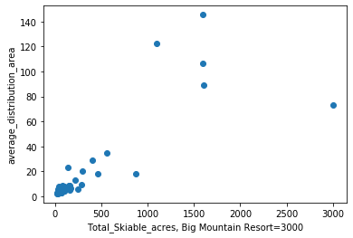

Fig.1 Total_Skiable_acres vs. area covered by people

Results showed that Big Mountain Resort @ 3000 acres had a much higher number than average resort. Therefore additional liftchair could help to attract more people and improve the coverage of area by people.

2. Liftchair Runs in Big Mountain Resort vs. Average resorts

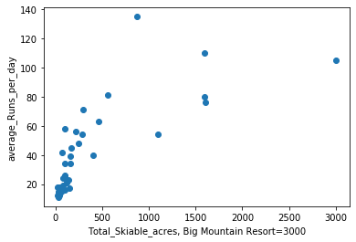

Fig. 2. Liftchairs runs comparison

Results showed that Big Mountain Resort @ 3000 acres had a faster liftchair runs than average resort. The would have a potential hazard in damaging the lifetime of liftchair. Additional liftchair could help to decrease the runs of liftchairs and extend the lifttime of current liftchair

3. Projected Liftchair needed

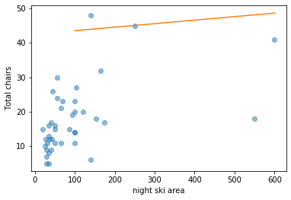

Fig. 3. Statistical Model Prediction

Statistical model was used to predict the liftchair needed. The results showed that at least 45 liftchair will be needed. Currently Big Mountain Resort has 41 chairs. Therefore at least four more chairs would be needed. This could be a quad liftchair or two double liftchairs.

4. Operation Cost

Currently there were 350000 people. Each people would pay average $70. Therefore the total revenue was $245000. The additional liftchair will cost $1450000, which is ~ 6% of the cost. However the additional liftchair could project to bring additional 21000 visitors this year. This could offset the expenses.